**Dear readers,**

**On behalf of the entire BORNBERG consortium, we are pleased to invite you to this first project newsletter.**

**A collaboration for a green city future started with a nice meeting!**

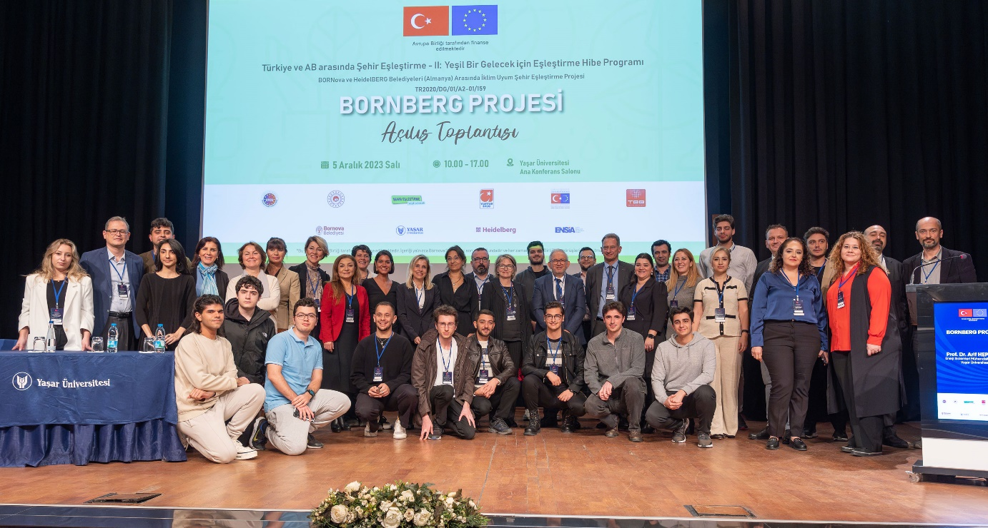

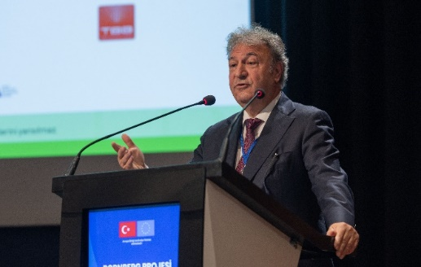Yaşar University, Bornova Municipality, Heildelberg Municipality officials and ENSIA (Energy Industrialists' and Businessmen's Association) came together at the opening meeting of the City Twinning II Grant Program between Turkey and the European Union - Green Future BORNBERG PROJECT. The project opening will be fun on December 5, 2023 and started with an informative opening meeting. The project, worth approximately 110 thousand Euros, will be completed in a one-year period and the two cities will support each other on Sustainable and Smart Development issues. Bornova SECAP (Sustainable Energy Climate Action Plan) is the project that Yaşar University and Bornova Municipality are working on. will be the output.

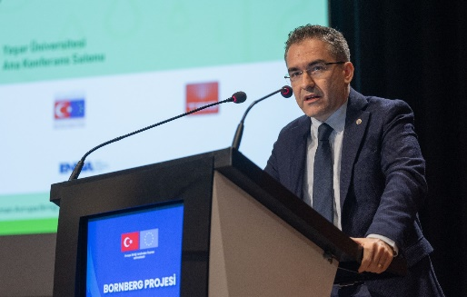Bornova Mayor Dr. Mustafa İduğ touched upon the contributions of the BORNBERG Project to the development of Bornova and Yaşar University Vice Rector Prof. Dr. Yiğit KAZANÇOĞLU underlined that cities play an important role in climate change.

Dr. attended the opening on behalf of Heildelberg Municipality. Raino WINKLER and Christine FIEDLER touched upon Heildelberg's environmental and climate adaptation process. ENSIA Chairman of the Board of Directors Alper KALAYCI touched upon the importance of the project and the cooperation.

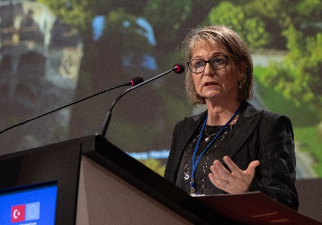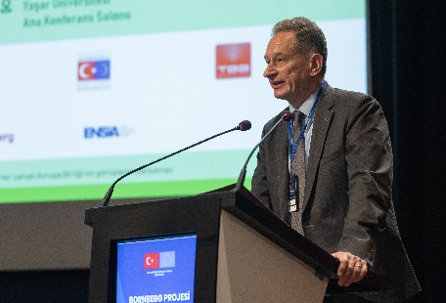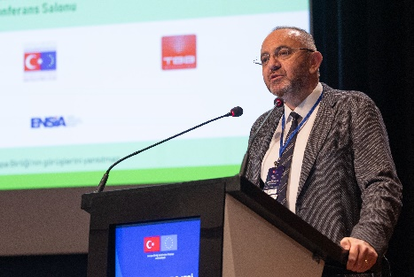

During the opening ceremony and the following expert presentations, expert presentations were made on both the current situation in Bornova and important points in the fight against climate change.

|  |  |
| --- | --- |
|  | Christine Fiedler  Office of Environmental Protection, Trade Supervision and Energy  City of Heidelberg  The City of Heidelberg Sustainability, climate protection and energy transition |
|  | Dr. Raino Winkler  Office of Environmental Protection, Trade Supervision and Energy  Climate Change Adaption  in Heidelberg |
|  | Prof. Dr. Arif HEPBAŞLI,  Yaşar University  Energy Systems Engineering  Investigation of SECAP |
|  | Fatma MESUTGİL  Bornova Municipality  Climate Change and Zero Waste Director  Sustainability studies in BORNOVA Municipality |
|  | Dr. Emin Selahattin UMDU  Yaşar University  Energy Systems Engineering  SECAP Preparations in Bornova |
|  | Hazal ÇOŞKUN  Energy Industrialists and Businessmen Association (ENSIA)  General coordinator  Energy Sector Potential and Opportunities in Izmir |