Town Twinning Between Türkiye and the EU-II: Twinning For a Green Future Grant Scheme
Climate Adaptation Town Twinning Between BORNova and HeidelBERG
(BORNBERG PROJECT)
TR2020/DG/01/A2-01/159

NEWSLETTER - 2

Dear readers,
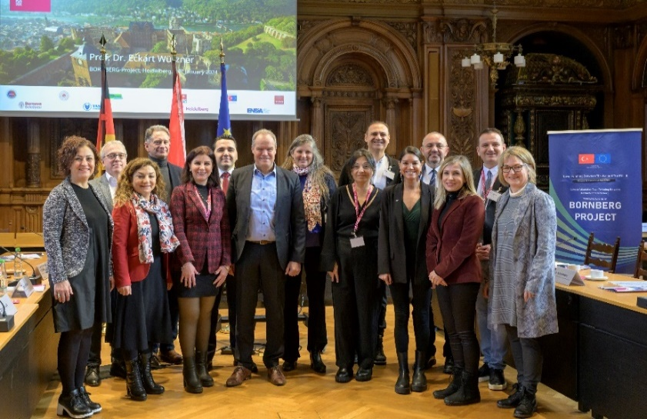
We are pleased on behalf of the entire BORNBERG consortium to share our 2nd newsletter with you.
“A collaboration for a green city future” continues with its new developments.
A working delegation of 11 people from Izmir went to Heidelberg.
A delegation of eleven people consisting of Yaşar University, Bornova Municipality, ENSIA (Energy Industrialists and Business Association) visited Heidelberg between 21 January and 26 January 2024 to meet with the project partners from Heidelberg and to ensure the sustainability of the project.
The delegation arrived in Heidelberg on the first day and met for a light dinner after settling in their hotel.
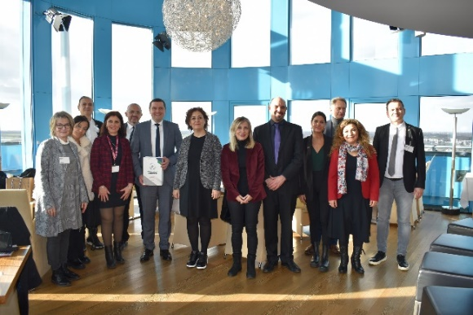
The technical and social trips that started on the 2nd day were first made to Bahnstadt, the Net-Zero-Passive House-Region, and then to the Municipal Service Building Stadtwerke Heidelberg Energy Park. The surprise of the day was the basketball match played with Heidelberg University academics in the evening.
The 3rd day started with a building tour and different presentations with Lothar Eisenmann, Philipp Wachter and Fabian Bergkteknik. Then, a visit was made to Heidelberg Innovation Park. Then, a tour of the concept and technical building was held, accompanied by Nila Gengatharan, a member of the Board of Directors of Heidelberger Energy and Citizens Cooperative. The last activity of the day was the official dinner where all partners gathered.
The day was started with Sabine Lachenicht's The City of Heidelberg and Dr Klaus Keßler'sKLiBA Presentations. Later, A meeting was held with the Mayor of Heidelberg, Prof. Dr. Eckart Würzner. After the team's program in this municipality, A welcome meeting was held accompanied by Prof. Dr. Breuer at SRH University Sky Lounge. The last meeting of the day was with Prof. Dr. Özdemir and Dr. Sterr. They made presentations about SRH University.
Day 5 was the last day, and after the BornBerg team meeting, a cultural tour of Heidelberg was held regarding the history of the city. The next day, after a productive trip, the Izmir delegation returned home.
“EU mission Label” to our partner, Heidelberg City
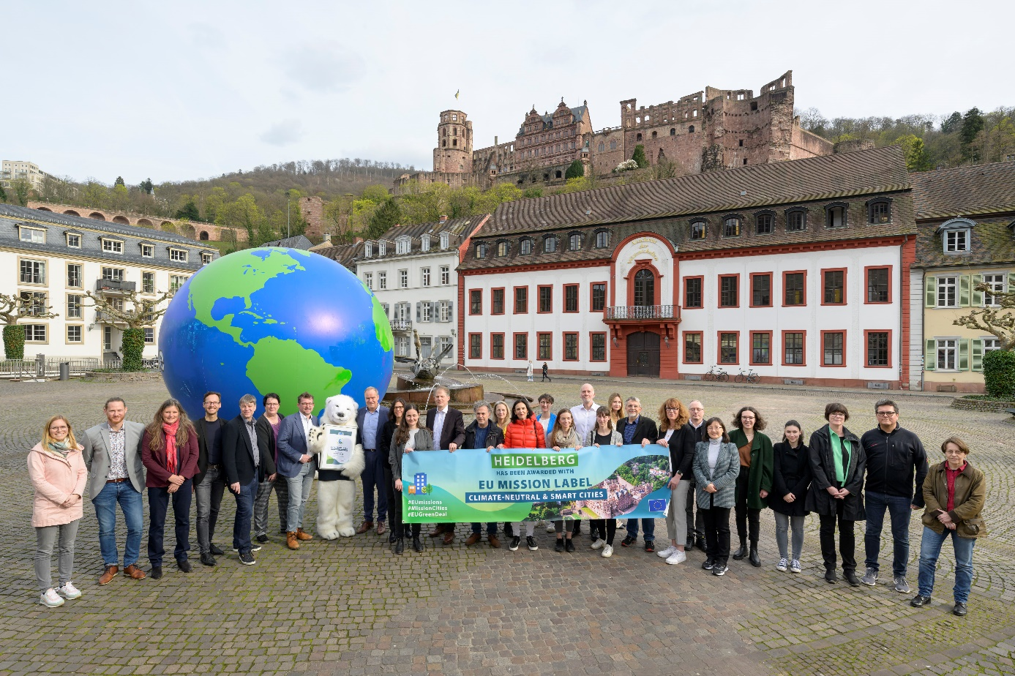
The city of Heidelberg is one of the ambitious European cities when it comes to climate protection: On Thursday, March 21, 2024, the European Union (EU) awarded the city the EU mission label of "Climate neutral and smart cities". With this award, the City of Heidelberg has privileged access to EU funding.
Many names worked shoulder to shoulder to achieve this success, and the cooperation partners welcomed this good news with a small celebration in the Prinz Carl building.
Eckart Würzner, Mayor of Heidelberg made a statement. He said: “We are very pleased with the award and feel encouraged to continue implementing climate protection measures in good cooperation with our partners from business, science, and civil society. Participation in the program also gives us the opportunity to network with other participating cities.”

