**Town Twinning Between Türkiye and the EU-II: Twinning For a Green Future Grant Scheme**

**Climate Adaptation Town Twinning Between BORNova and HeidelBERG**

**(BORNBERG PROJECT)**

**TR2020/DG/01/A2-01/159**

**NEWSLETTER - 3**

**We are happy to share our 3rd Newsletter on behalf of the entire BORNBERG consortium**

**“A collaboration for a green city future” continues with its new developments.**

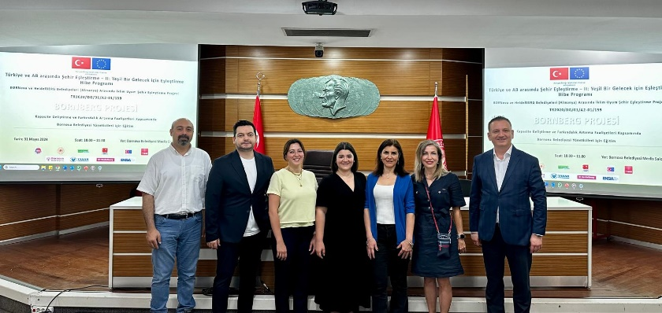**The survey conducted on the knowledge level of Bornova Municipality personnel on the climate and energy crisis and the planned studies in this field enabled 853 personnel to participate and highlight this issue.**

**As a result of the survey, it was seen that the staff knowledge level and climate change awareness were higher than the Türkiye average. Despite this, the need to provide information about the basic definitions and processes in this increasingly complex concept has emerged. The prominent issues in the needs analysis were determined as the SECAP process, sustainable cities, sustainable society and carbon footprint. Based on these results, two separate trainings were held for Bornova Municipality Council members and administrative staff, who are the decision makers.**

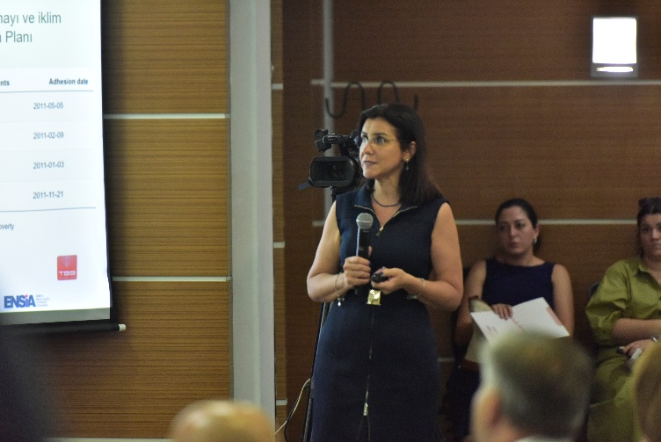 **The training for managers was held in Bornova Municipality on May 31, 2024, using the training documents prepared by the Yaşar University team. In this awareness training, Prof. Dr. Nurdan YILDIRIM and Dr. Lecturer Member Emin Selahattin UMDU told more than 50 participants about the direct effects of climate change on municipal activities and the impact of the climate on Bornova today and in the coming years. In addition, in these trainings, the costs of not taking sustainability actions and the social and economic benefits of these actions were discussed with real-life examples.**

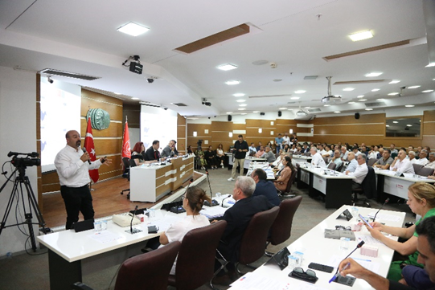**Following this training, an awareness training was held for Council members and other internal stakeholders, who are decision makers in Bornova Municipality, on July 1, 2024. In this training, basic information about the effects of climate change on Bornova, decision-making tools and preventive measures against global warming was conveyed. In both trainings, Bornova Municipality Mayor Mr. We would like to thank Ömer EŞKİ and senior management representatives for their participation and sensitivity and support regarding climate change.**