**Town Twinning Between Türkiye and the EU-II: Twinning For a Green Future Grant Scheme**

**Climate Adaptation Town Twinning Between BORNova and HeidelBERG**

**(BORNBERG PROJECT)**

**TR2020/DG/01/A2-01/159**

**NEWSLETTER - 4**

**Dear readers,**

**4. We are pleased to share our newsletter with you on behalf of the entire BORNBERG consortium.**

**The cooperation for a green city future ended with the 2nd Turkish delegation visit to Heidelberg and a magnificent closing meeting.** 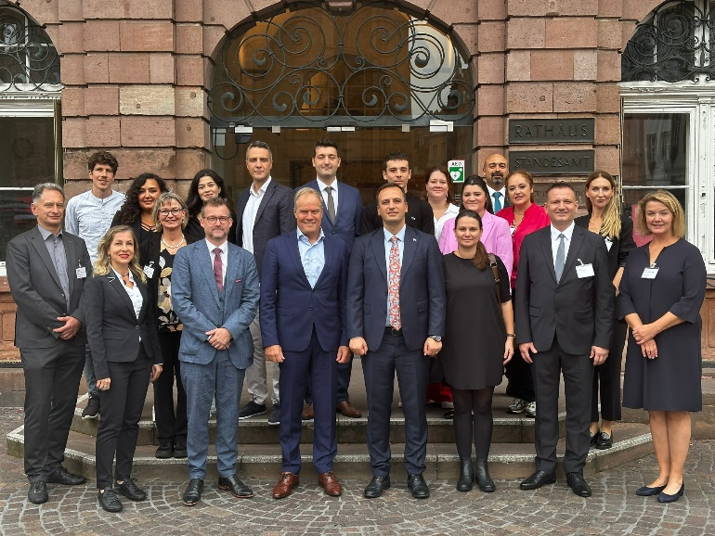

The delegation consisting of Bornova Municipality, Yaşar University and ENSIA (Energy Industrialists and Business Association) visited Heidelberg between 22 – 27 September 2024 to meet with the project partners from Heidelberg and expand the last information exchanges before the completion of the project.

The delegation arrived in Heidelberg on the first day and met for a light dinner after settling into their hotel.

In the program that started on the second day, Mayor Mr. Prof.Dr. Meetings were held with Eckart WÜRZNER, Vice President Raoul Schmidt LAMOONTAIN, and the Heidelberg delegation working on the giyim, kişi, şahıs, bina, insanlar içeren bir resim

Açıklama otomatik olarak oluşturulduBornBerg Project. Bornova Mayor Ömer Eşki made a speech on cooperation for climate action between two cities. After a light lunch, information was given about Heidelberg Municipality's Climate Change Adaptation Strategy Concept and Heat Action Plan. The day's tiredness was relieved with a dinner with a city view, hosted by the Municipality of Heidelberg.

gökyüzü, bulut, dış mekan, ağaç içeren bir resim

Açıklama otomatik olarak oluşturulduOn the third day, in the morning, Carbon Neutral Municipal Applications Energy Control was discussed, and presentations were listened to by the Heidelberg delegation. Then, after a short city tour, a Solar Power Boat trip was made, and information was obtained about the plans and energy program for river heat pumps in Heidelberg.

Day four passed more intensely and started with a technical tour of Heidelberg's sustainability and renewable energy-friendly IT business. Then, we went to the Wave house Campell Heidelberg building, which Is currently world’s largest 3D printed building. Later, Associate Professor from Yaşar University Ebru ALAKAVUK, Dr. Lecturer Member Emin Selahattin UMDU and Dr. Duygu ÇINAR UMDU Prof. from Heidelberg University. Dr. He had a meeting with Vice Rector Prof. Dr. Alexander SIEGMUND on cooperation in Sustainability Education.

The last day was day five, and the BornBerg team made a technical trip to the New Congress Centre Building and Bahnstadt District to see Climate-Friendly Construction and Building Technologies on-site. The next day, in the morning, delegation returned to İzmir.

giyim, kişi, şahıs, takım elbise, adam, insan içeren bir resim

Açıklama otomatik olarak oluşturuldu**Magnificent Closing Meeting of the Successful Project**

Many guests and participants other than the project partners attended the project closing meeting hosted by Yaşar University on October 15, 2024.

On behalf of the Municipality of Heidelberg, Dr. Raino WİNKLER and Christine FİEDLER also attended the closing meeting and made their last Bornberg project visit.

At the end of the closing meeting, a protocol ceremony was held between Bornova Municipality and ENSIA, and a Sectoral Workshop was held after a break.

The workshop, attended by academia, SMEs, Chambers of Industry/Profession, local governments, and NGOs, discussed how climate change and its effects are reflected in the sectors and made various analyses.